**Guidelines for Poster Preparation**

**General aim and format**

A poster is a graphically based approach to presenting research or program information. In presenting your research/program with a poster, you should aim to use the poster as a means for generating active discussion.

**Design, layout, and content recommendations**

•  The poster size of 3 feet by 5 feet (36 in x 60 in) is recommended.

•  The poster is recommended to be oriented in the "landscape" position.

•  Text should be readable from five feet away. Use a *minimum* font size of 18 points.

•  A banner displaying your poster title, name, and department (or class, if appropriate) should be positioned at top-center of the board (see Figure 1).

•  Make it obvious to the viewer how to progressively view the poster. The poster generally should read from left to right, and top to bottom. Numbering the individuals panels, or connecting them with arrows is a standard "guidance system" (see Figure 1).

•  Leave some open space in the design. An open layout is less tiring to the eye and mind.

•  Make sure that any visual can "stand alone" (i. e., graph axes are properly labeled, maps have north arrows and distance scales, symbols are explained, etc.).

•  Make sure that the text and the visuals are integrated. Figures should be numbered consecutively according to the order in which they are first mentioned in the text.    
Each visual should have a *brief* title (for example: Figure 1- Location of study area).

•  Depending upon the stage or nature of your project, the text could also include sections on future research plans or questions for discussion with viewers.

•  Cite and reference any sources of information other than your own.

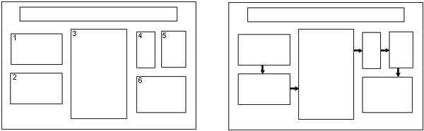

Figure 1: Conventional layouts for a poster. Long panel at top-center is title/author banner. Individual panels can be connected by numbers and arrows. Also, note the use of space between panels to achieve visual appeal. (*from*: C.W. Connor, 1992, The Poster Session: A Guide for Preparation: U. S. Geological Survey Open-File Report 88-667.)

*Adapted from the University of Pittsburg